Cars of The Fairfax Family and Friends

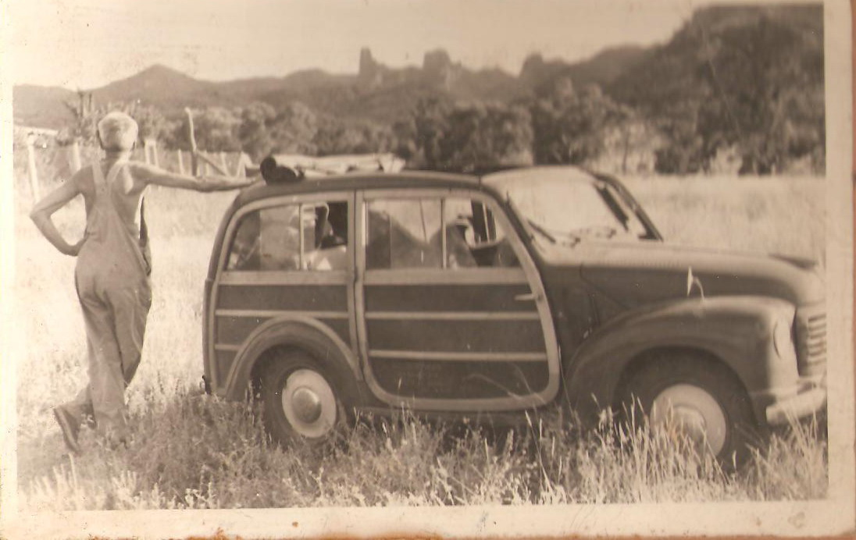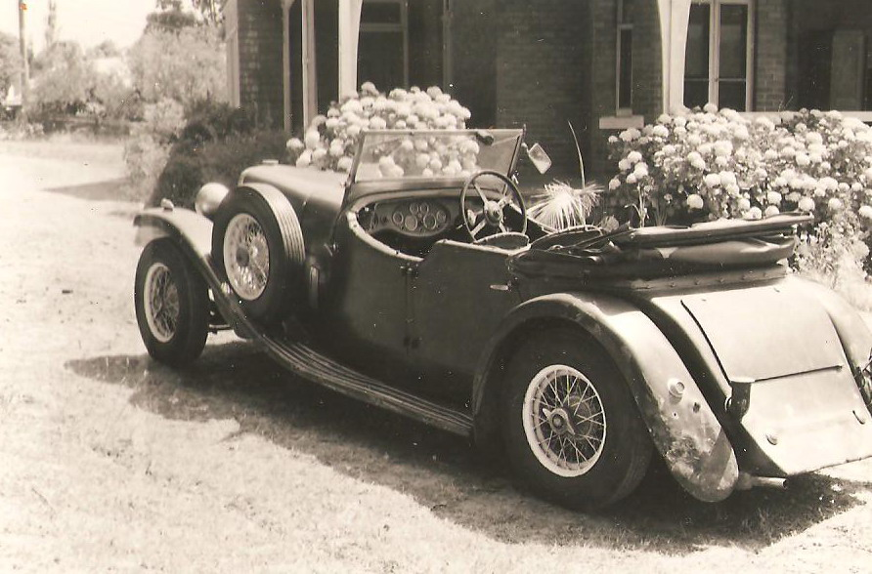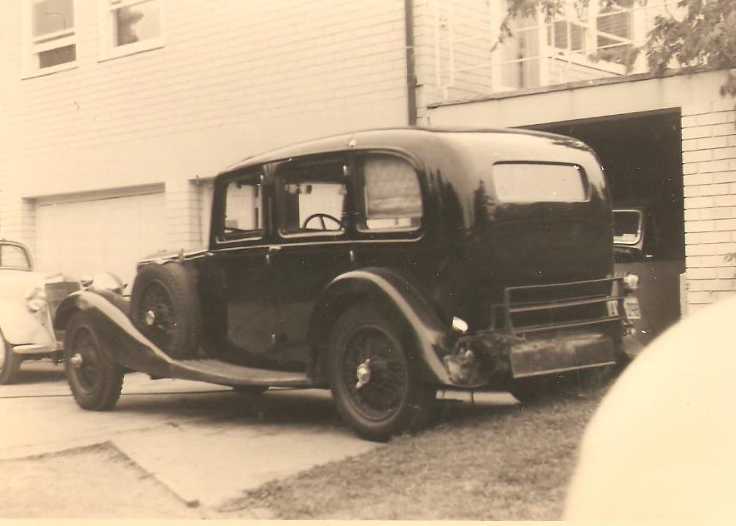

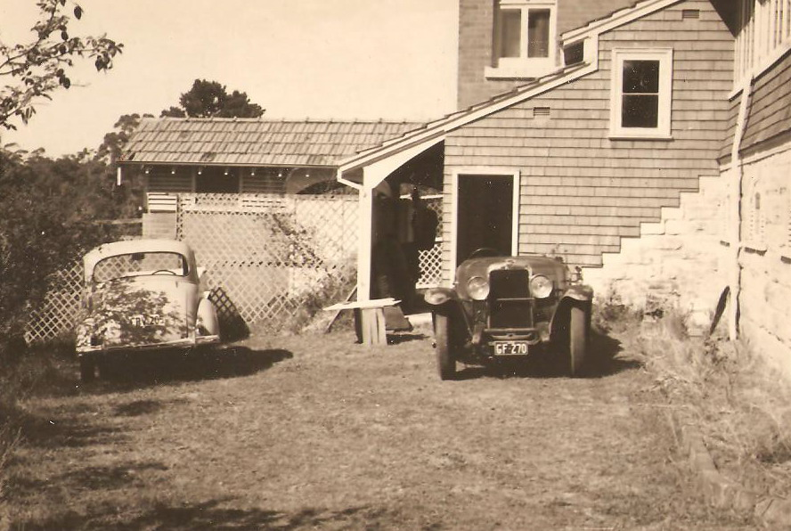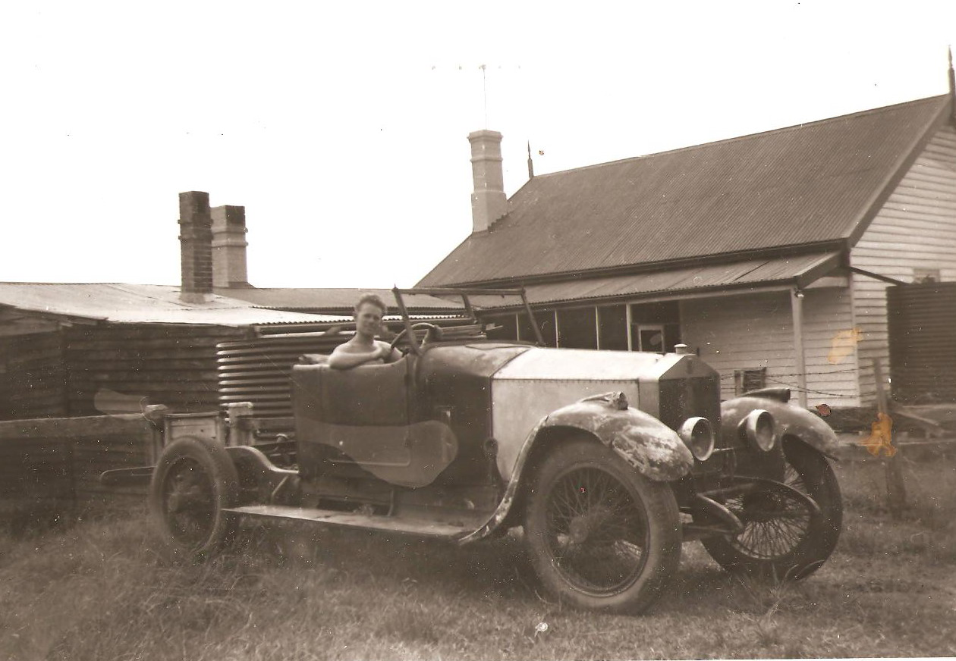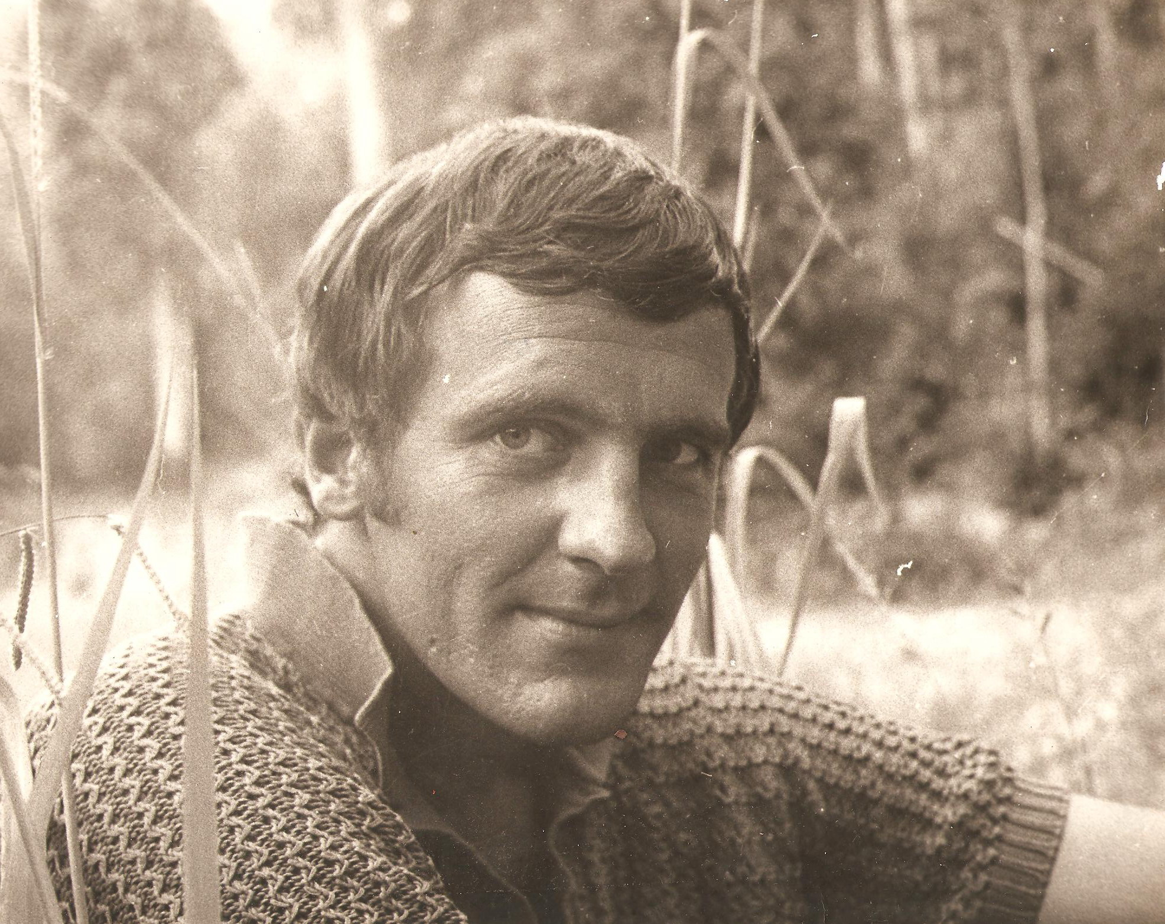

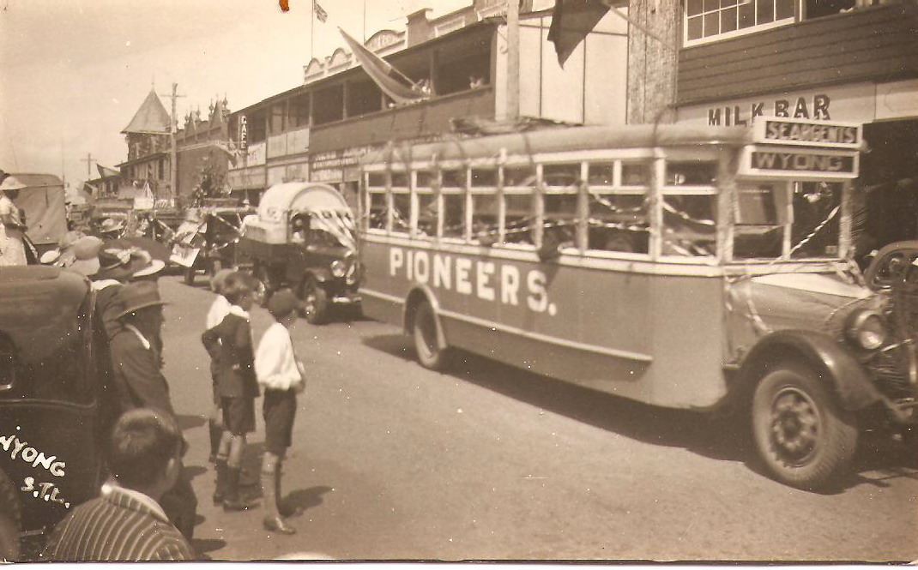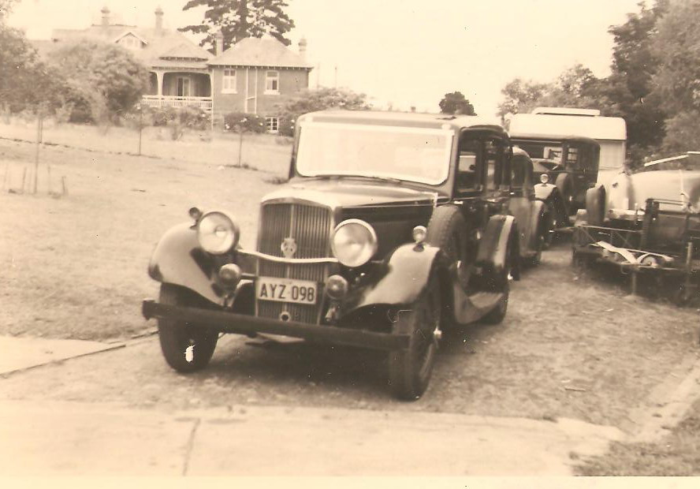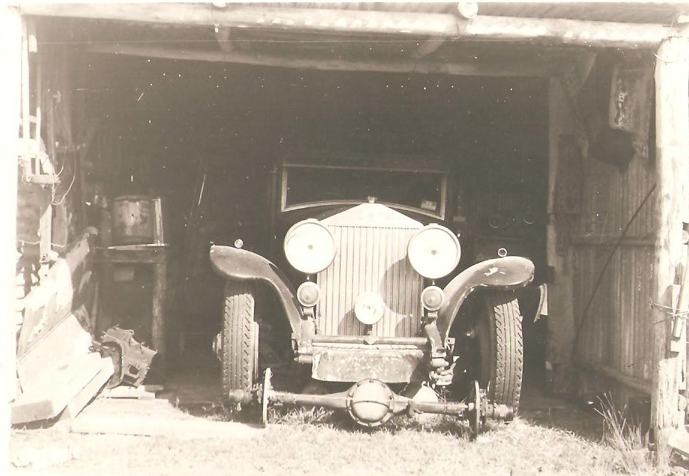
By Chris Coyle
Published By Cleaver Donkey Publishing House.

Cars Of The Fairfax Family And Friends By Chris Coyle.

Copyright © 2009 Cleaver Donkey Publishing House and Chris Coyle all rights reserved. No part or the whole of this book or it’s text or any image may be copied or transmitted or forwarded on or publicly shown or distributed in any way or by any means, through electronic or through any form of media without the copyright owners or the publishers permission. Any such breach of the copyright act will be met with the full force of the law.

This book is compiled from a collection of hundreds of photos, clippings, previously owned by Stella Fairfax. We hope you enjoy this newly discovered collection of Australian History, kept safe by a now deceased member of the Fairfax Media Empire. Many of the photos were not captioned or dated so may not be in correct date order.

Important notice please wait until the photos pop onto place as you scroll down the page otherwise you will miss photos.

The Following photos are in order of appearance in the scrap books not in order of date.

Alvis Firefly

Alvis

Alvis Firefly and Morris Minor

Rolls Royce PII These days this would be called a barn find.

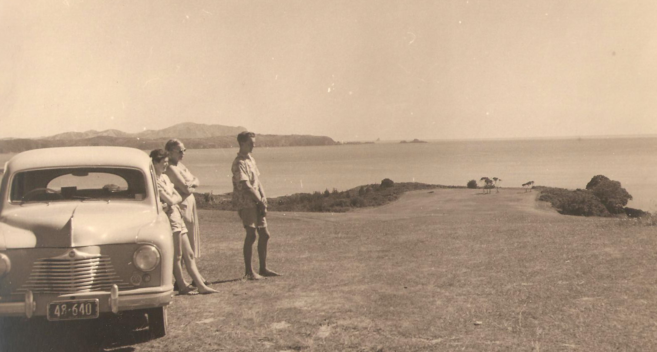

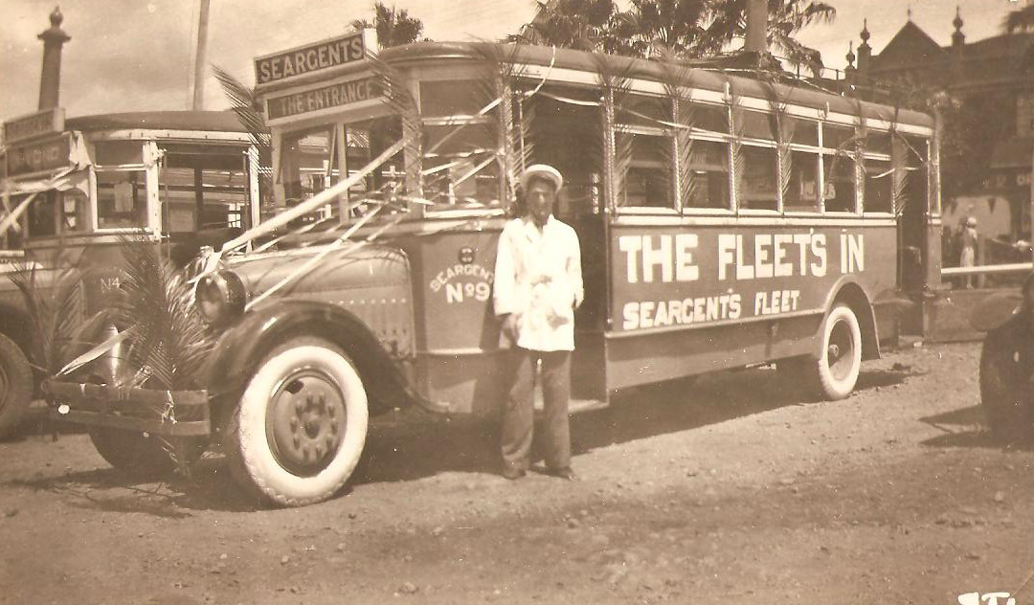

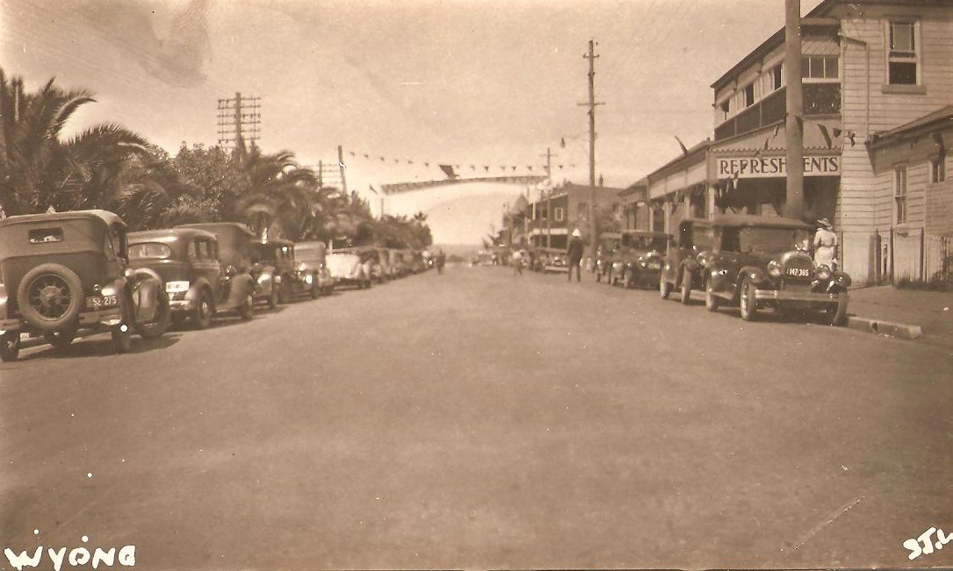

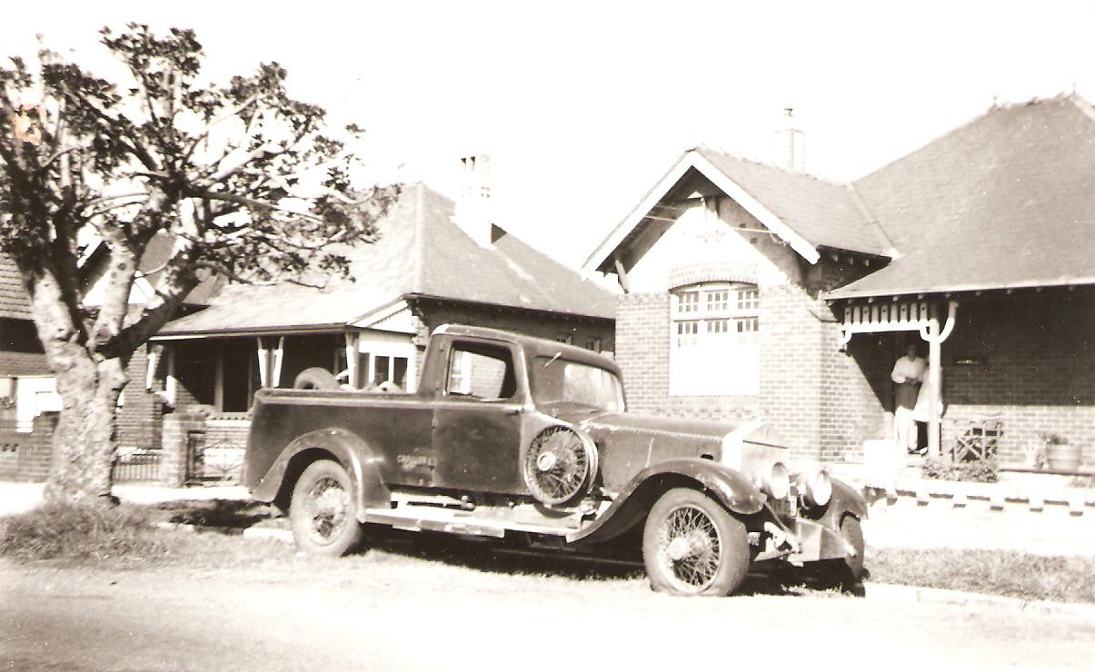

How many Rolls Royce Utes do you see?

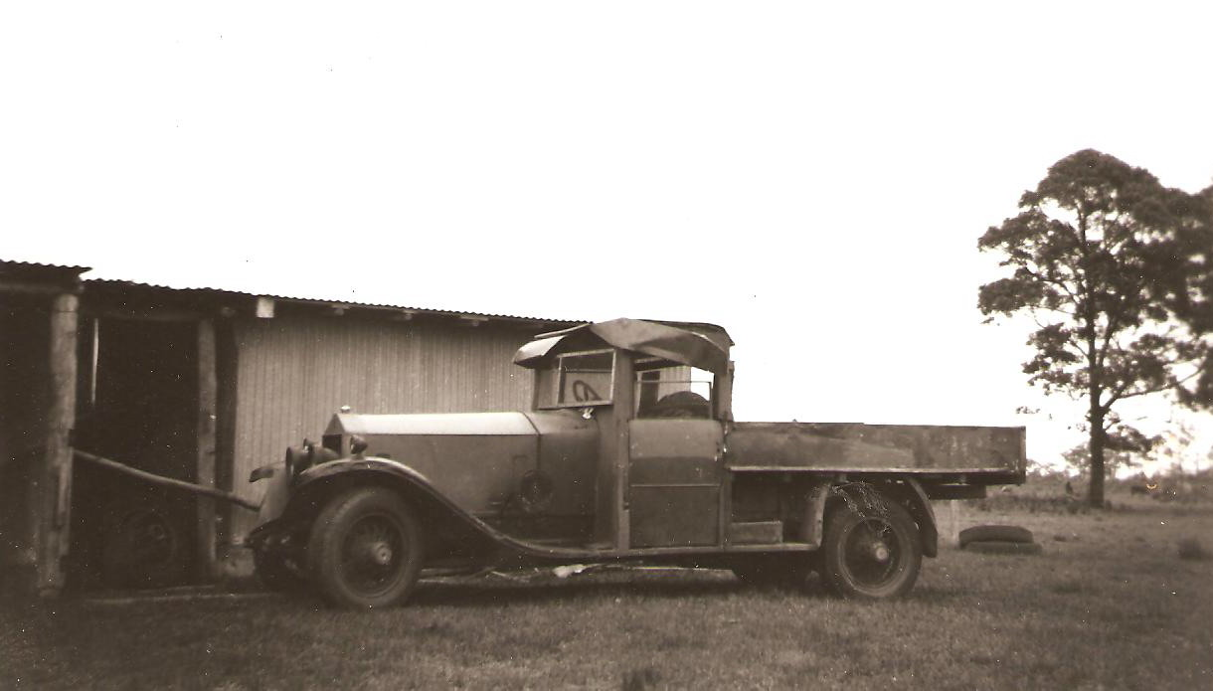

Or Trucks like this?

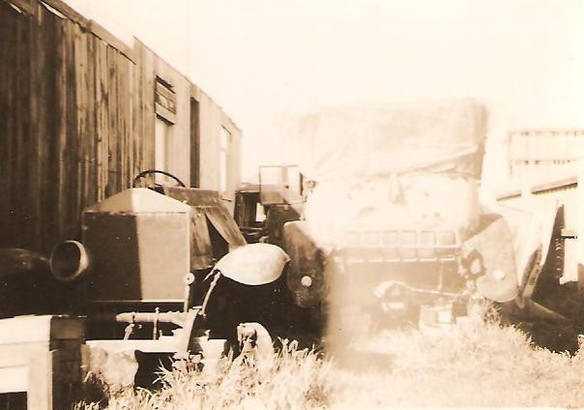

Photo taken in Melbourne

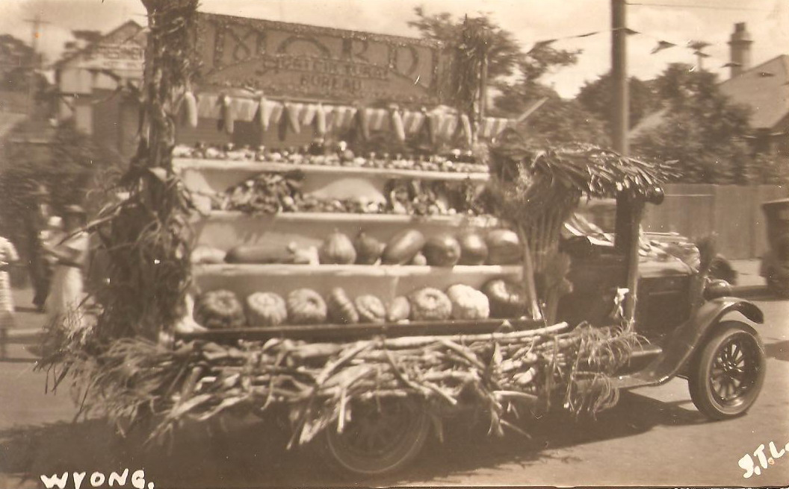

Fruit and veg sales before the Supermarket!

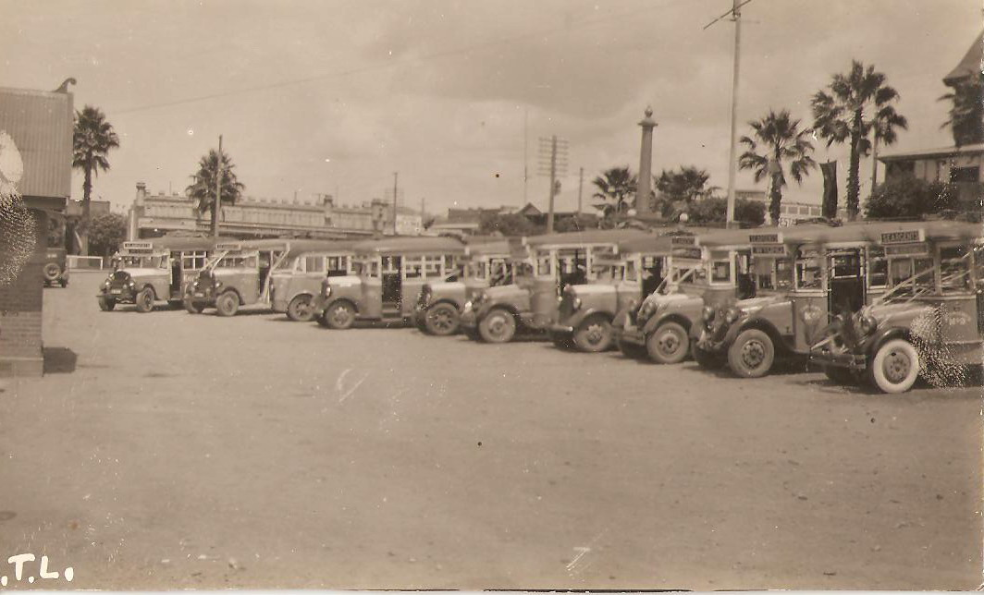

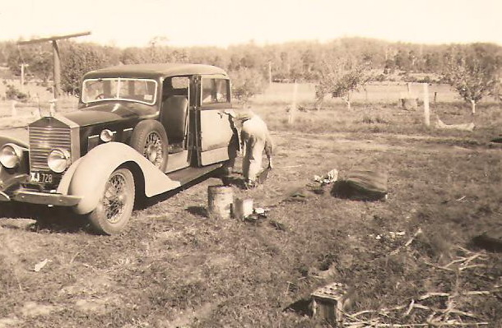

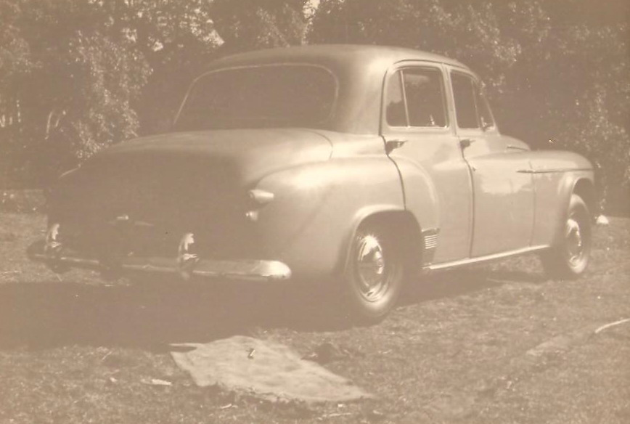

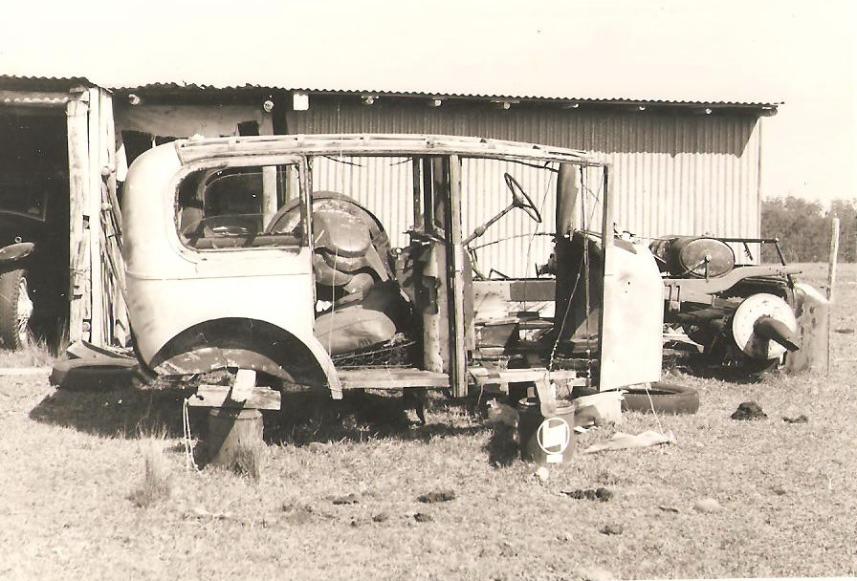

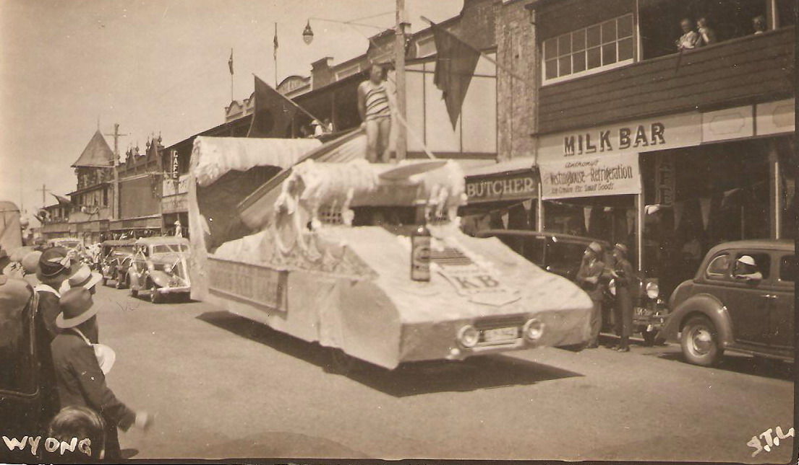

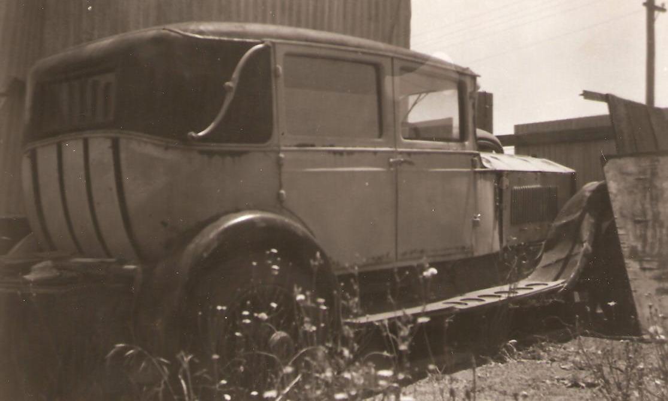

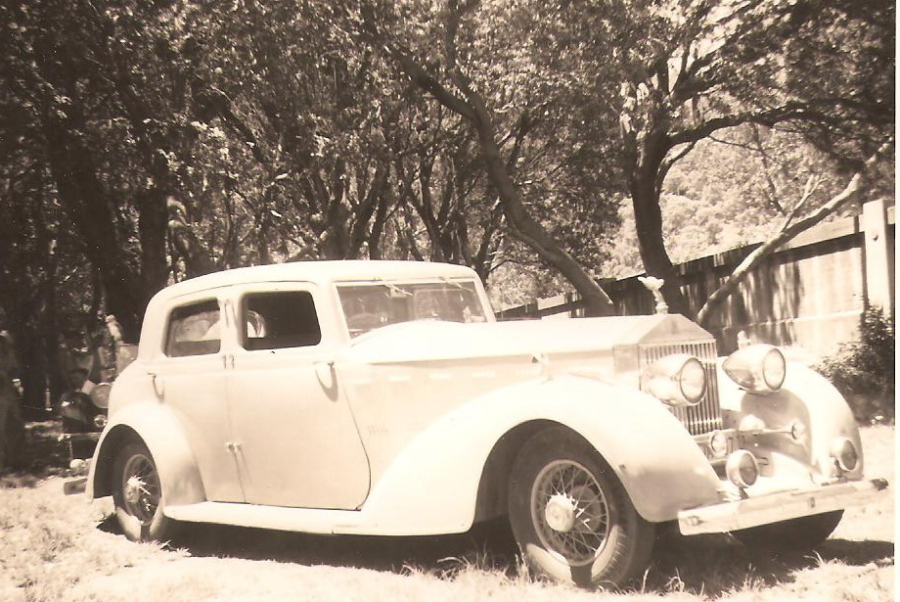

Rolls Royce P1 At Turramurra when owned by Morris Lamrock

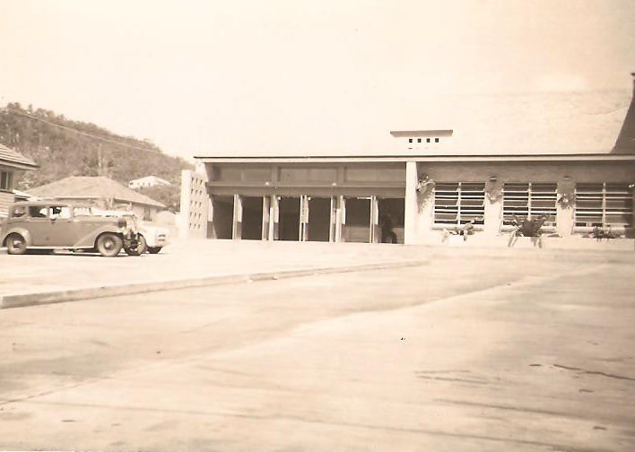

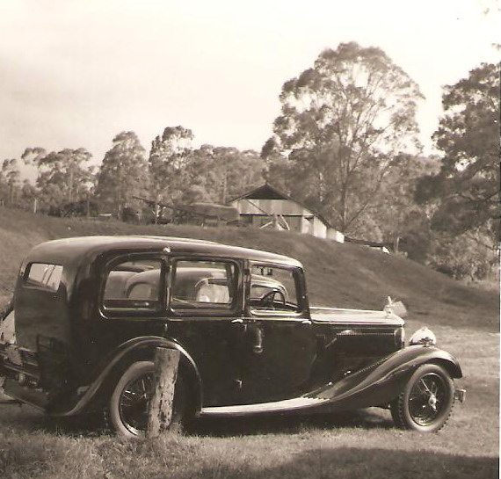

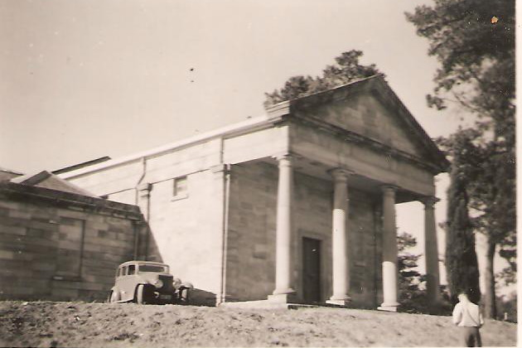

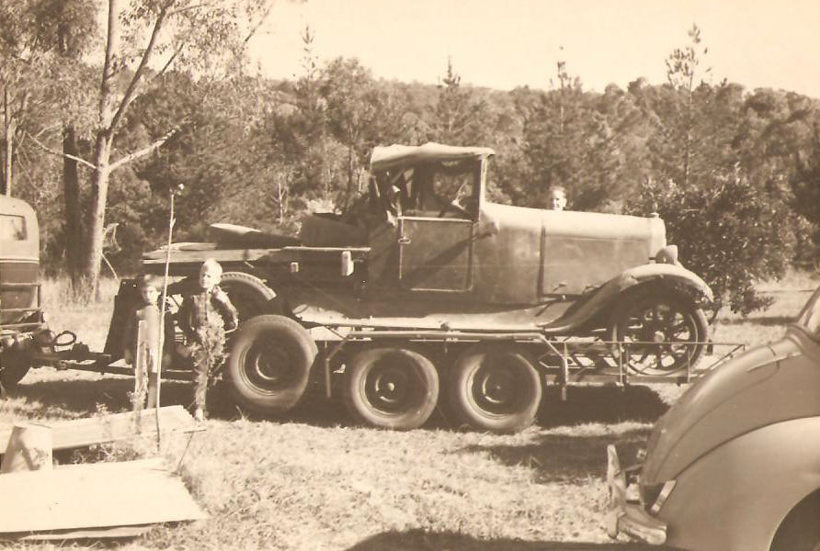

Austin 20

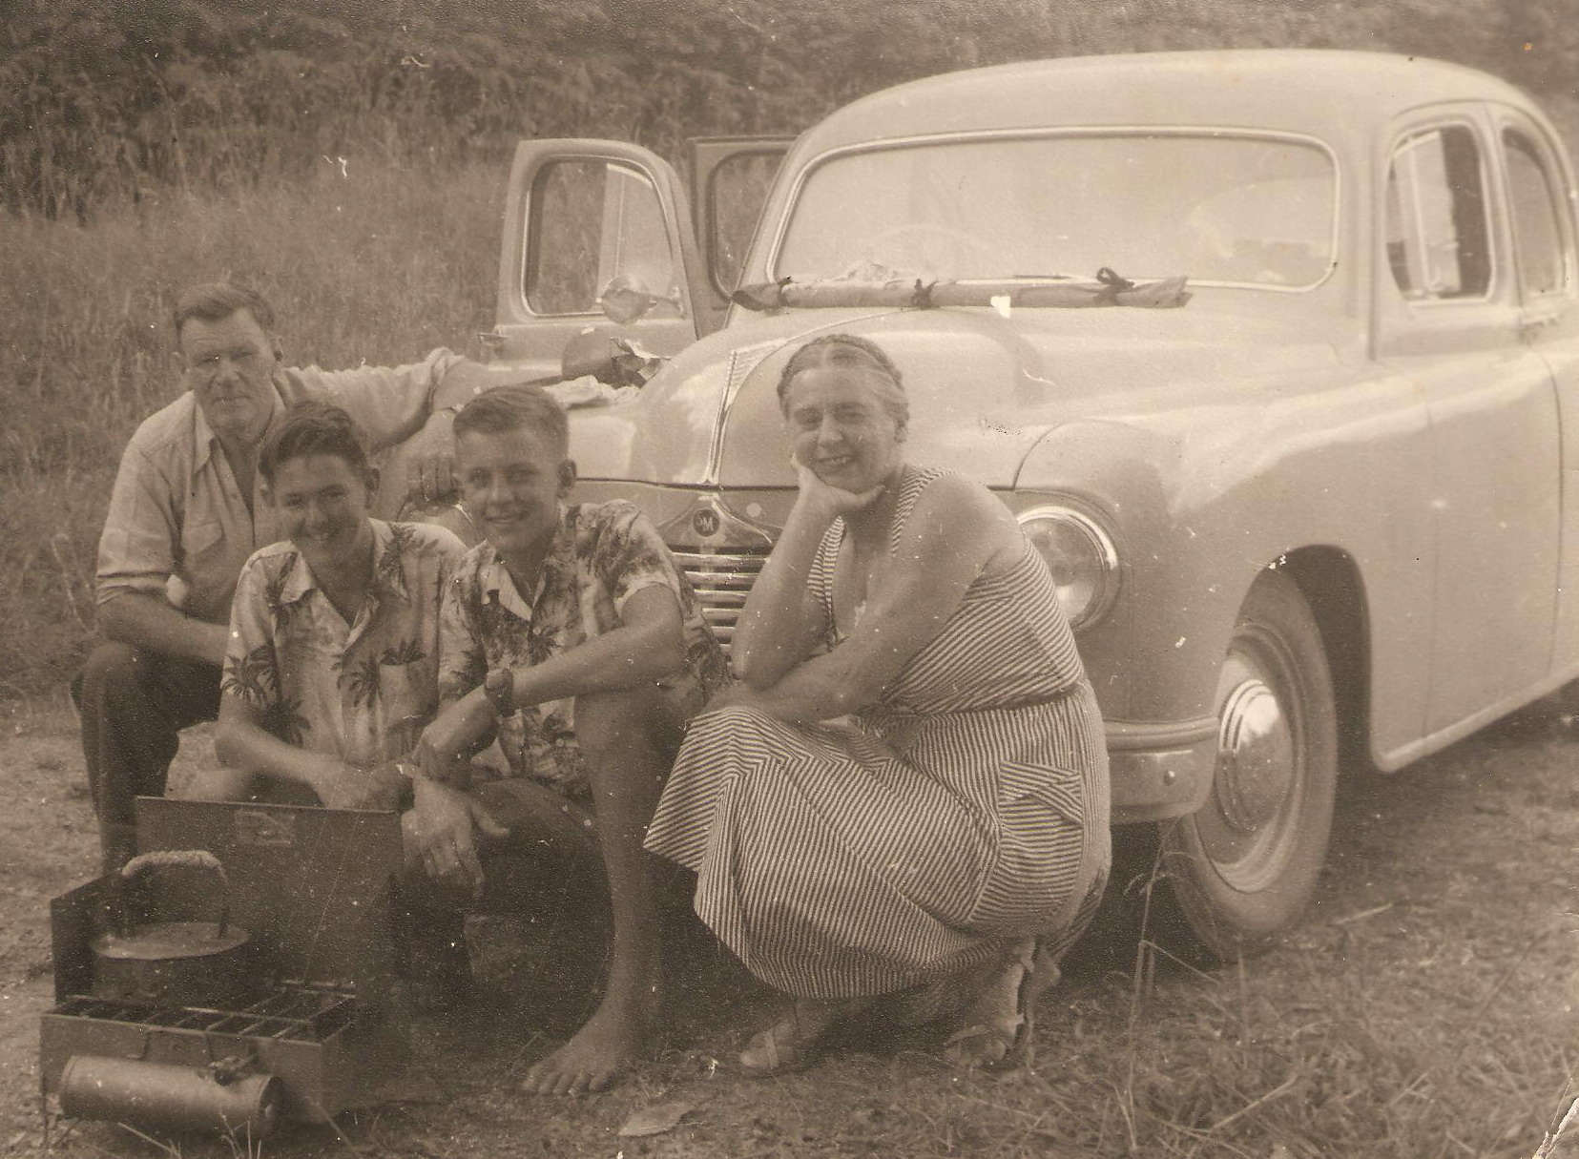

Stella Fairfax on the right

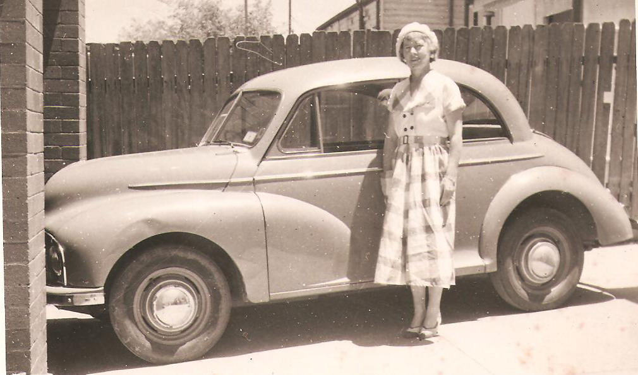

Morris low light

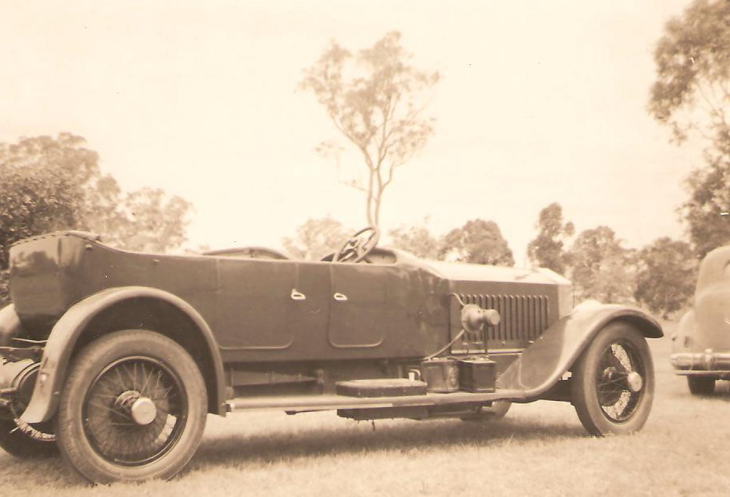

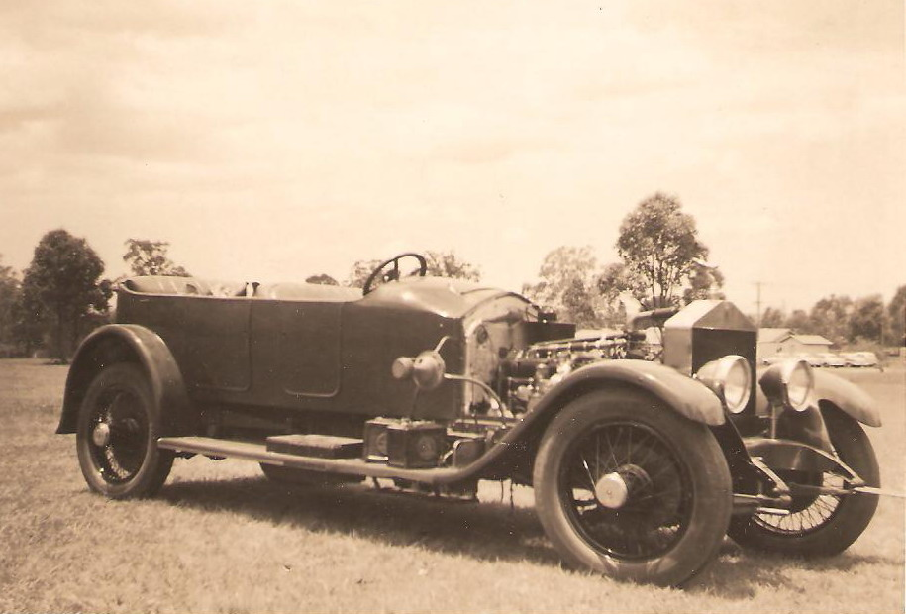

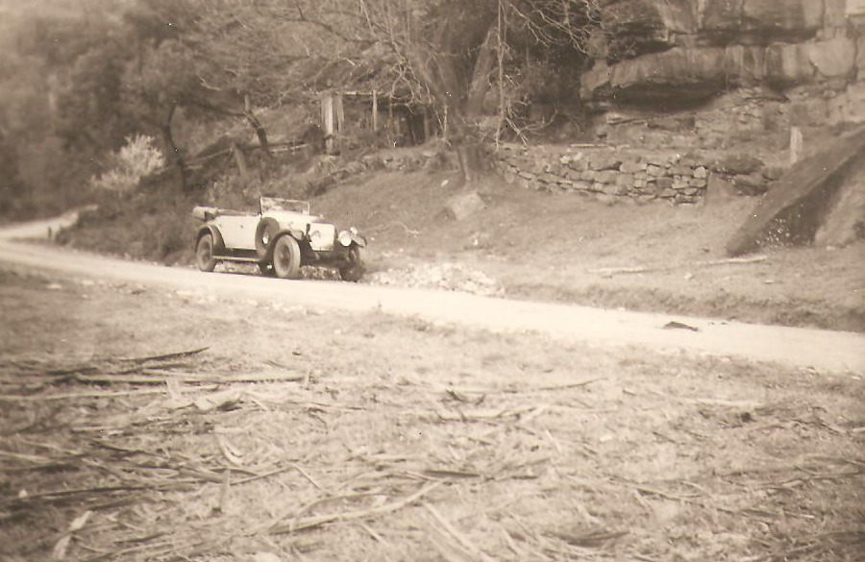

Rolls Royce 20 near St Albans N.S.W

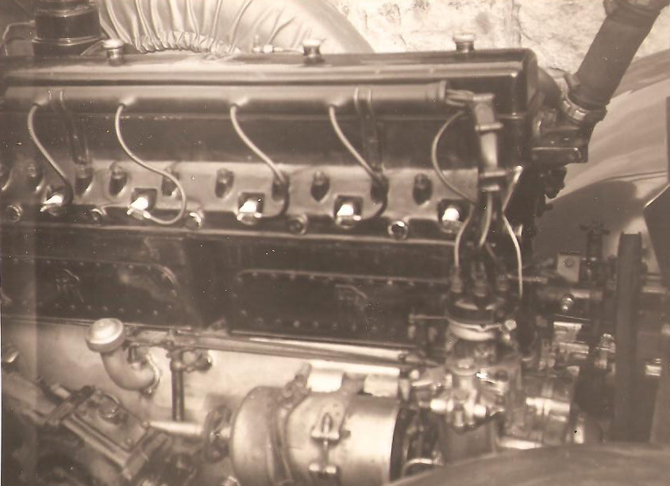

Rolls Royce P1.5

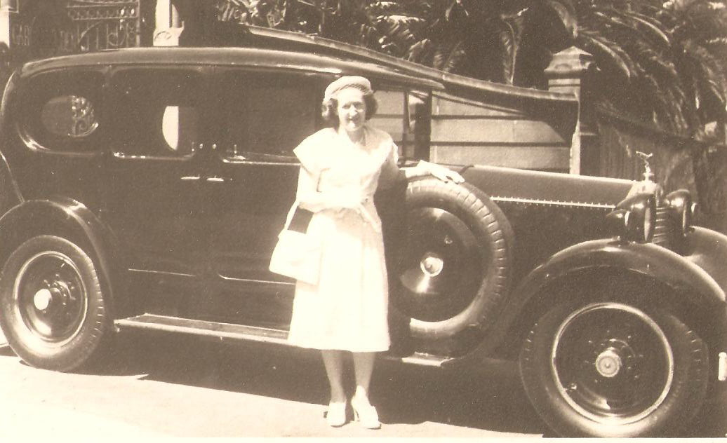

Mrs Jean Sevenoakes with Rolls Royce 20

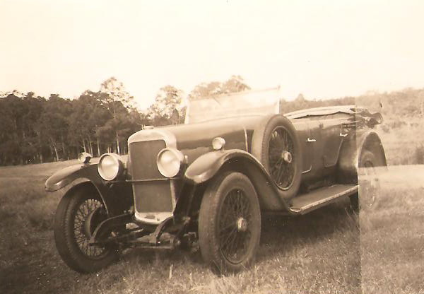

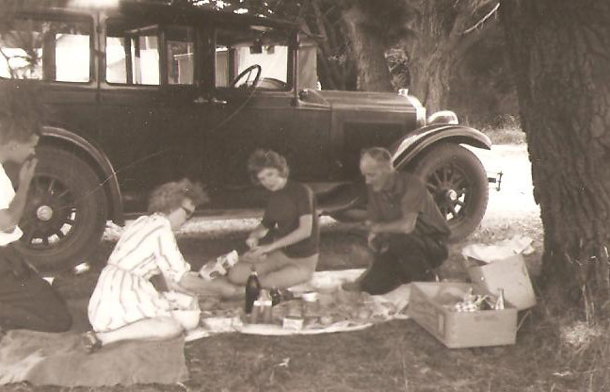

Sunbeam in the Blue Mountains

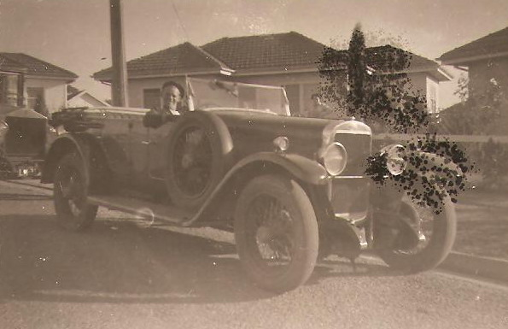

Sunbeam 14/50

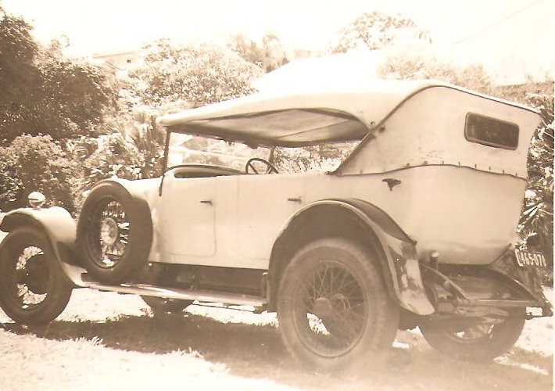

Rolls Royce 20

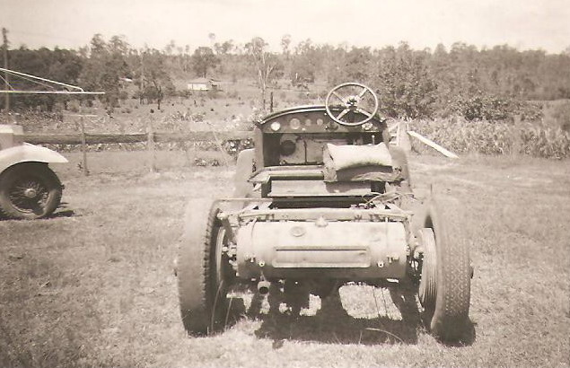

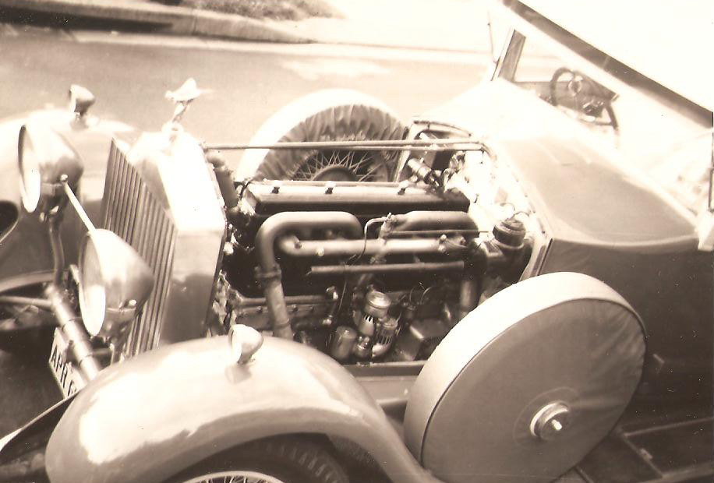

Rolls Royce P 1.5

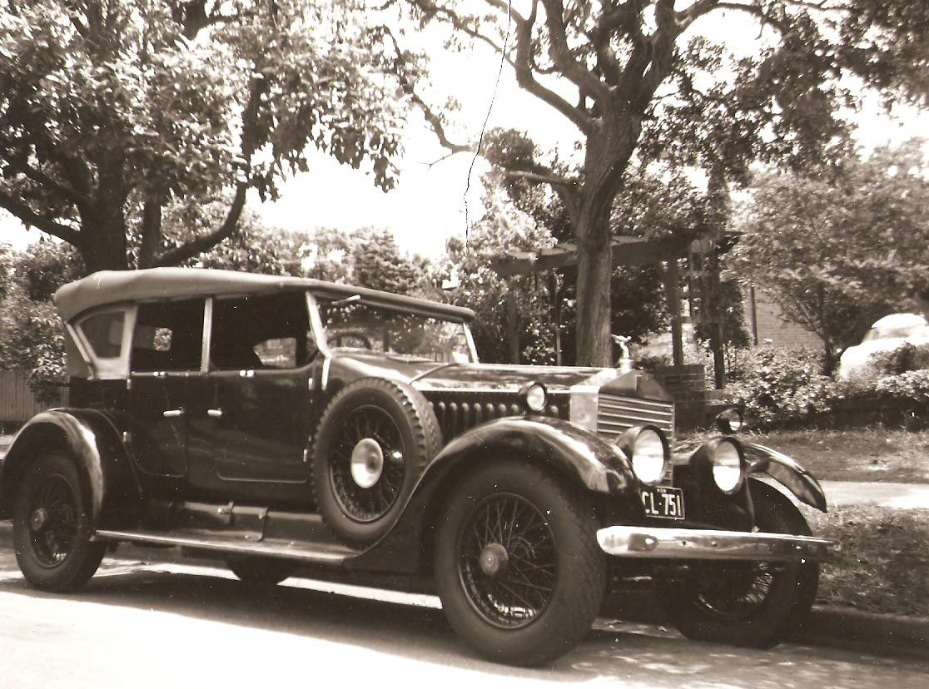

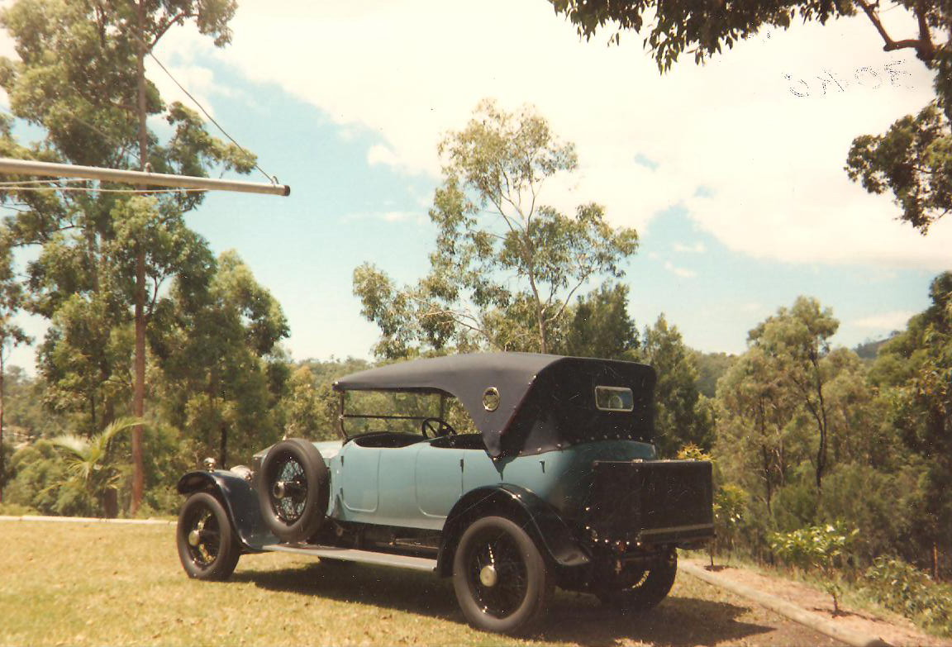

Note the old Hills Hoist in the back yard a real classic, like the subject.

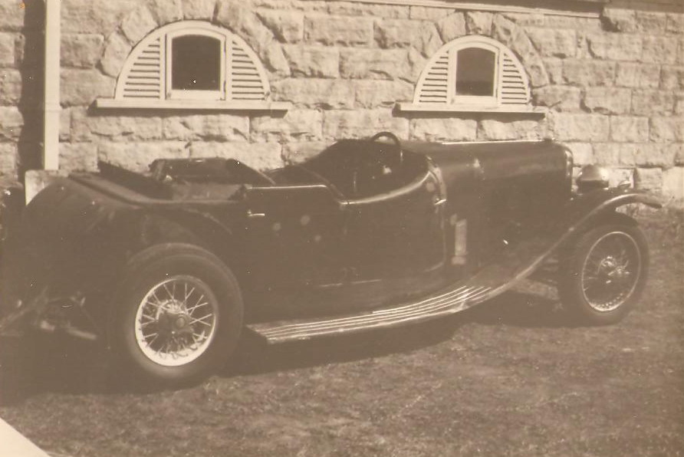

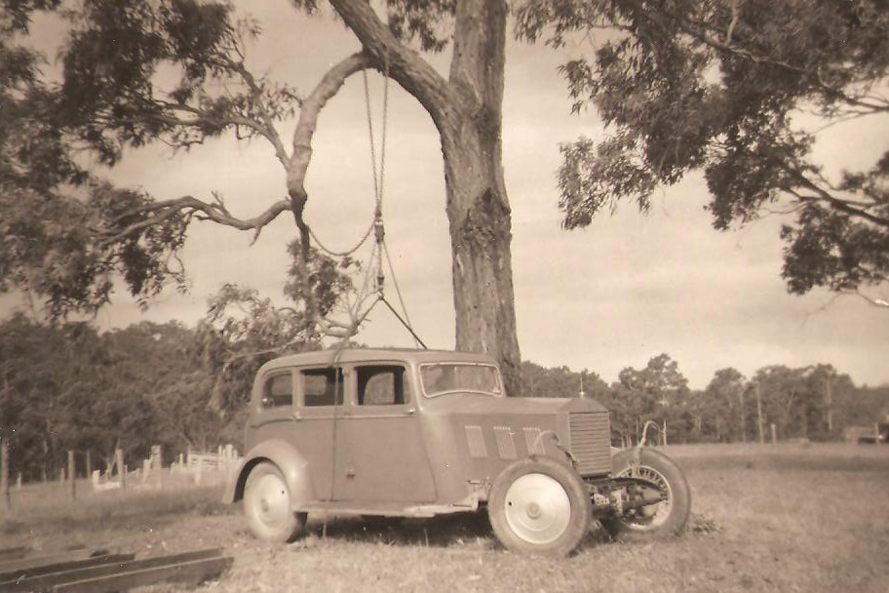

Rolls Royce with Saloon body by Moriarty Sydney

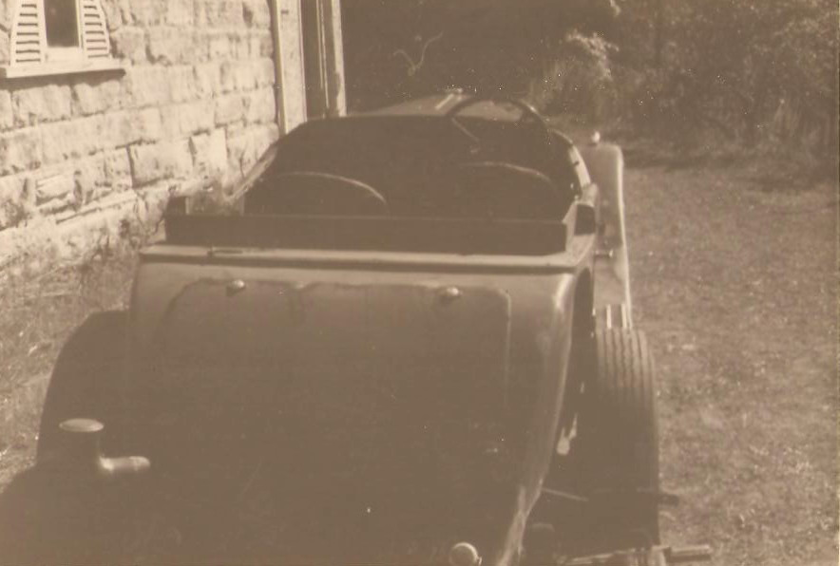

Alvis Firefly

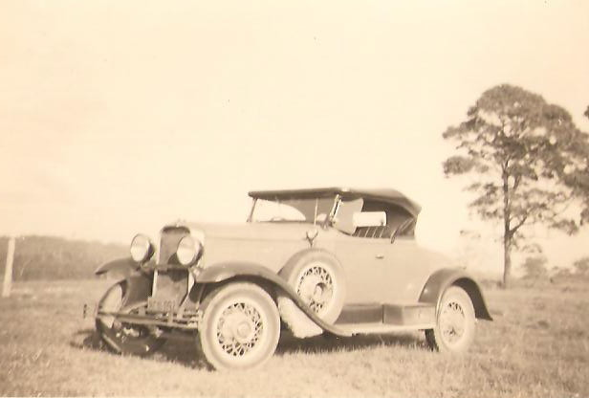

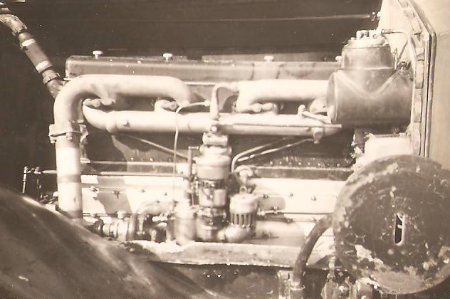

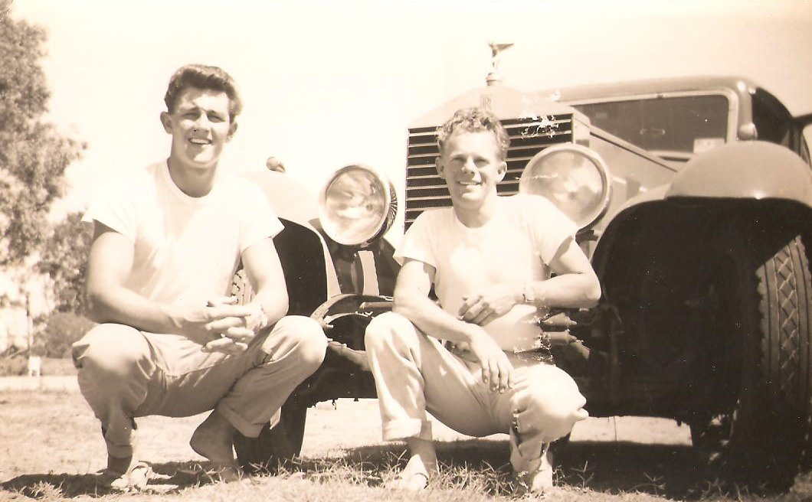

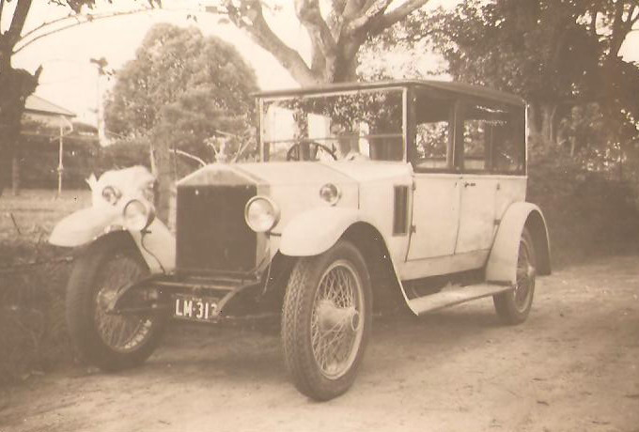

Rolls Royce T Strackan P Harwin

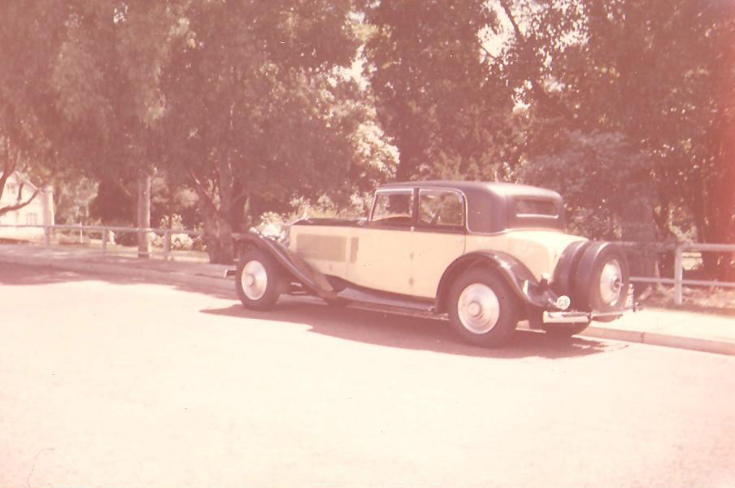

Rolls Royce P2 in 1975 Owner Jack Jefferys

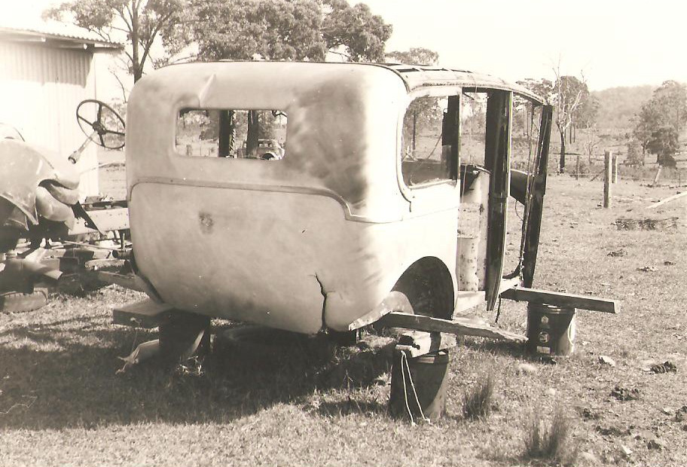

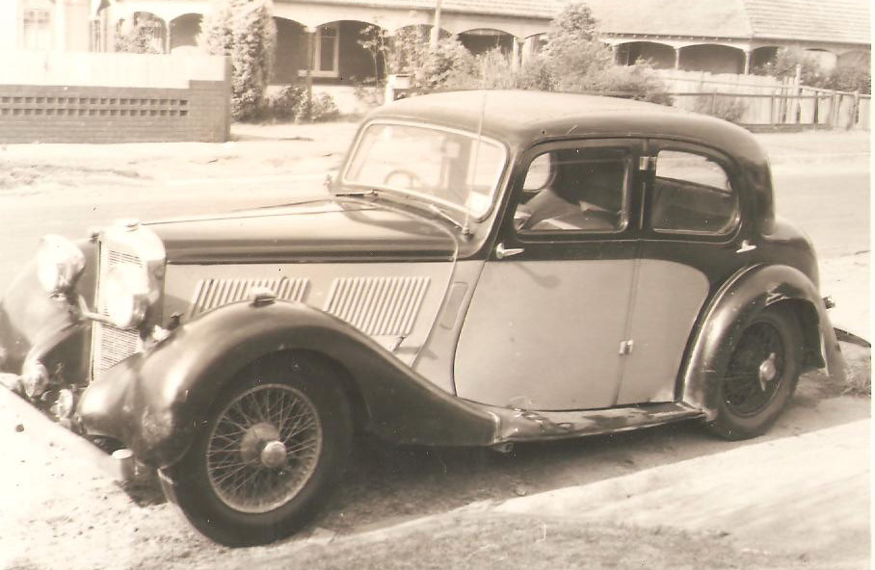

Alvis 12/70

We hope you enjoyed the over 50 photos

Quite a selection of some fantastic cars including a Rolls Royce ute and other modified Rolls Royce cars and various other makes, as you would expect from the Fairfax media family.
To order more copies simply write to Clever Donkey Publishing House P.O. Box 5069 Eagleby 4207 or phone 0403 441 631 for wholesale prices or bulk discount prices.

